**NeoCare**

Arani Pittu, Nila Prabhu, Anika Vasisht

Riverwatch Middle School

Grade 8

December 8, 2023

**Abstract**

The main goal of NeoCare is to be of aid to mothers and their newborn children who need proper diagnoses for potentially dangerous gaps in growth and other harmful factors that could affect the health of the mother and child. The main question that was being asked in this process was, “How can mothers get specialized neonatal care for their babies and themselves?”. If we create a neural network model to individualize postpartum care, then the general health of the mother and their respective newborn will improve because by addressing and explaining the physical factors that affect the health of the baby and mother, the use cases in question will be able to understand the medical situation of the child properly; achieving this will relieve stress from the mother and lead to more effective and efficient care for the child. The procedure will be a neural network and predictive Python model to point out gaps in growth and potential physical disorders. The results of the procedure were that the predictive models and neural network models accurately and successfully predicted different health disorders in three different use cases. The data concluded that the hypothesis was correct as the predictive model, in parallel to the neural network model and graphs, helped the theoretical mothers identify different gaps in growth of their children early on so that they could be treated more effectively and efficiently by licensed professionals.

**Introduction**

**Purpose**

The experiment was conducted to test the accuracy of a predictive model and discern if it could accurately identify different neurological or physical disorders in a child using CDC growth charts and classification of what the different disorders should look like.

**Problem**

How do mothers get individualized neonatal care for their babies?

**Research**

The information gathered was a discovery of many different genetic disorders associated with the growth of a child, specifically of the measurements provided in the CDC charts, such as growth-for-age, head circumference-for-age, etc. The first thing that needed to be explored was the importance of each measurement found in the CDC graphs, as well as focusing and choosing certain graphs to use. Through this research, it was discovered that a child’s body mass index is not an accurate representation of the health of said child due to frequently misclassifying “metabolic health, which is linked to how much fat a person has and how it is distributed.”(Shmerling, 2023, 1), as well as not being linked to any major disorders. The next step of the research consisted of compiling as many disorders as possible to potentially use for the models. Some of the researched syndromes were Prader-Willi Syndrome, Microcephaly, and Turner’s Syndrome. These disorders all had symptoms that affected physical growth, which is what the models that were created monitored. For example, microcephaly and macrocephaly can be characterized “as a head circumference less than two standard deviations and greater than two standard deviations from the norm, respectively”(Badik, Bevington, Wroblewski, 2015, 1). Macrocephaly specifically is known as “above 2 standard deviations, which is above the 97th percentile”(Jones, Debopam, 2023, 1). The mathematical characterization of microcephaly is the head circumference being more than two percentiles below the 5th percentile head size on the CDC benchmark charts. Turner’s Syndrome, however, is characterized as being above the 95th percentile of weight for a given age from the benchmark chart. Six different disorders were researched to be potentially used for the predictive models. Turner’s Syndrome, Prader-Willi Syndrome, Cushing’s Syndrome, Microcephaly/Macrocephaly, Down Syndrome, and Noonan Syndrome). The last and final part of the research was finding the data and expected output to compare to the user input in the predictive model. The graphs and baseline graphs being used were from the Center for Disease Control website(CDC, 2017, 1), which led us to baseline graphs and tables that could be turned into CSV(comma-separated value) files and inputted into the models to find an averaged value of disorders the child may be susceptible to. Using all of the given information, it was concluded that by creating the predictive model and inputting all of the research, the mothers could be given individualized care through the risk assessment of the different disorders and the importance of varying growth measurements.

**Hypothesis**

If we create an AI model to individualize postpartum care, then the general health of the mother and their respective newborn will improve because by addressing and explaining the physical factors that affect the health of the baby and mother, the use cases in question will be able to understand the medical situation of the child properly; achieving this will relieve stress from the mother and lead to more effective and efficient care for the child.

**Methods**

**Variables**

**Independent:**

The independent variables of the experiment are the measurements specific to a given child, or the values being inputted into the neural network model.

**Dependent:**

The dependent variable of the experiment is the NeoScore, which is an average taken of four different mathematical equations used to assess the risk of three different debilitating medical disorders in a child.

**Constants:**

The constants of the experiment are the coding language(Python), the CDC growth charts, and the platform on which the trials took place(VS Code).

**Materials**

* VS Code
* Computer Access
* Access to Wi-Fi
* Github Account
* CDC Growth Charts (data)
* Use Cases
* Python

**Procedures**

Define Objective

* Aim is to develop a website that predicts potential genetic disorders and gaps in growth in children during the neonatal period.

Step 1: Data Preparation

* Collect CDC growth data specific to length-for-age, weight-for-age, and head circumference-for-age.
* Prepare a diverse dataset representing various children’s measurements(age in months, length in cm, weight in kg, sex, and head circumference in cm)

Step 2: Pivot

* Instead of a website, create a working predictive model

Step 3: Model Development

* Develop a Python script to input each child’s measurements in VS Code
* Implement logic to compare these measurements against CDC data:

- Determine if the length is below the 5th percentile for Turner Syndrome.

- Check if weight exceeds the 95th percentile for Prader-Willi Syndrome.

- Assess if head circumference exceeds two standard deviations from the norm for Microcephaly and Macrocephaly.

Step 4: Scoring System Implementation

* Implement a scoring system(the NeoScore) to quantify the likelihood of each syndrome
* For each syndrome, calculate individual scores based on the deviation from CDC’s normative data on a scale between 0 and 25

Step 5: Testing the Model

* Create a sample dataset that intentionally gets flagged
* Test the model using the prepared sample dataset to predict potential syndromes
* Record flags(indicators for potential syndromes) and calculate the NeoScore for each of the five children

Step 6: Data Visualization

* Create visual representations of the model’s predictions using data visualization tools(Matplotlib and Seaborn in Python)

1. Heatmaps(displays the distribution of NeoScores for each syndrome across the different children)
2. Stacked Bar Charts(represents the cumulative NeoScores for each case)
3. Visualization of the Equation(written form of the equations as well as the sum of all equations averaged to find the NeoScores)
4. Benchmark Charts(the importance of these graphs are to show where the child is in relation to the growth curve of the CDC national average)
5. Tables visualizing the sample data set and their respective NeoScores

Step 7: Analysis and Interpretation

* Analyze the visualized data to interpret the predictions made by the model
* Compare the results against the CDC’s expected growth path to evaluate the accuracy of the model

Step 8: Review and Refinement

* Review the full process to identify the potential improvements
* Refine the model and the procedure as necessary to enhance the accuracy

Step 9: Documentation

* Document every step of the process(include the details of the model development, testing and analysis processes)
* Read it through and clarify for optimum replication

**Results**

Baby 1: 7.79 NeoScore(25 on Prader-Willi Syndrome, 5.8 on Macrocephaly)

Baby 2: 3.75 NeoScore(15 on Microcephaly)

Baby 3: 6.88 NeoScore(20 on Prader-Willi Syndrome, 7.2 on Macrocephaly)

Baby 4: 6.29 NeoScore(21 on Prader-Willi Syndrome, 4.3 on Macrocephaly)

Baby 5: 8.49 NeoScore(4.7 on Turner’s Syndrome, 25 on Prader-Willi Syndrome, 4.5 on Macrocephaly)

**Table(s)**

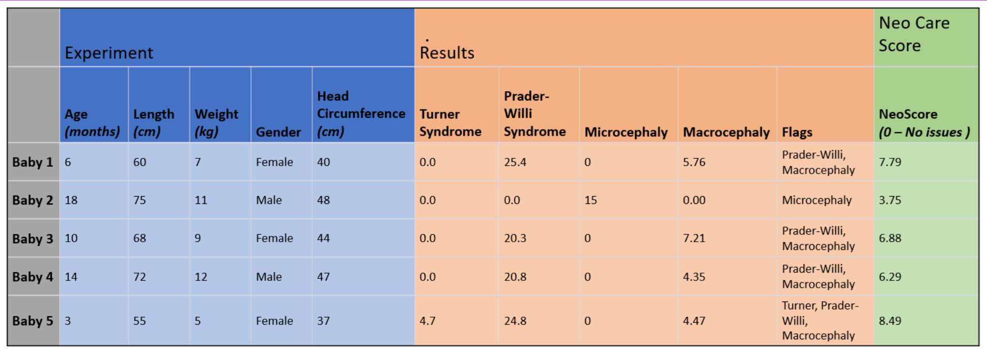

**Graph(s)**

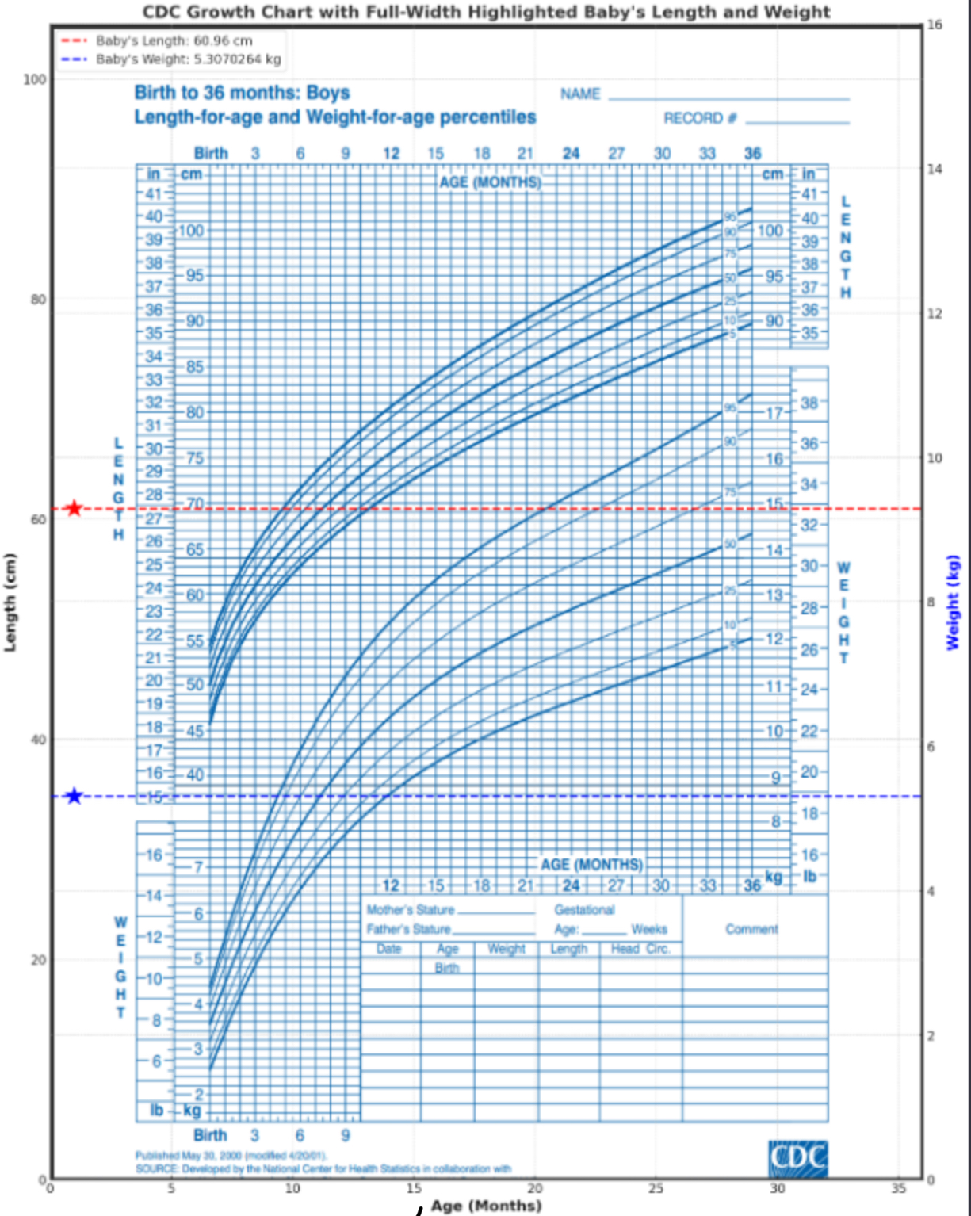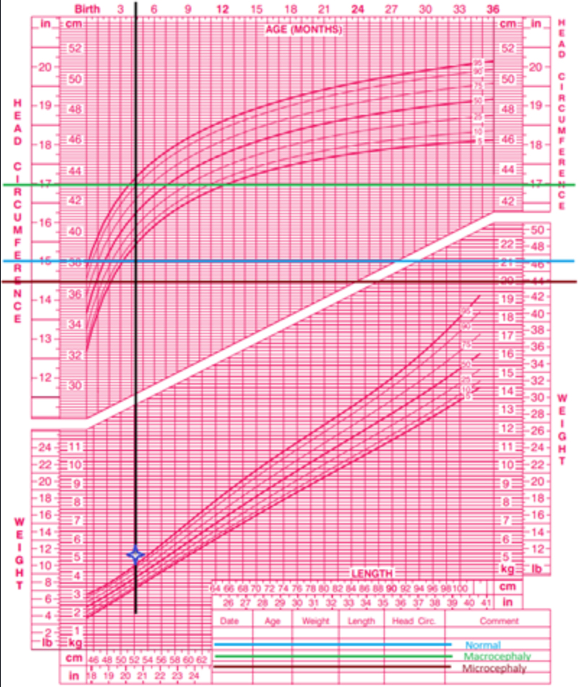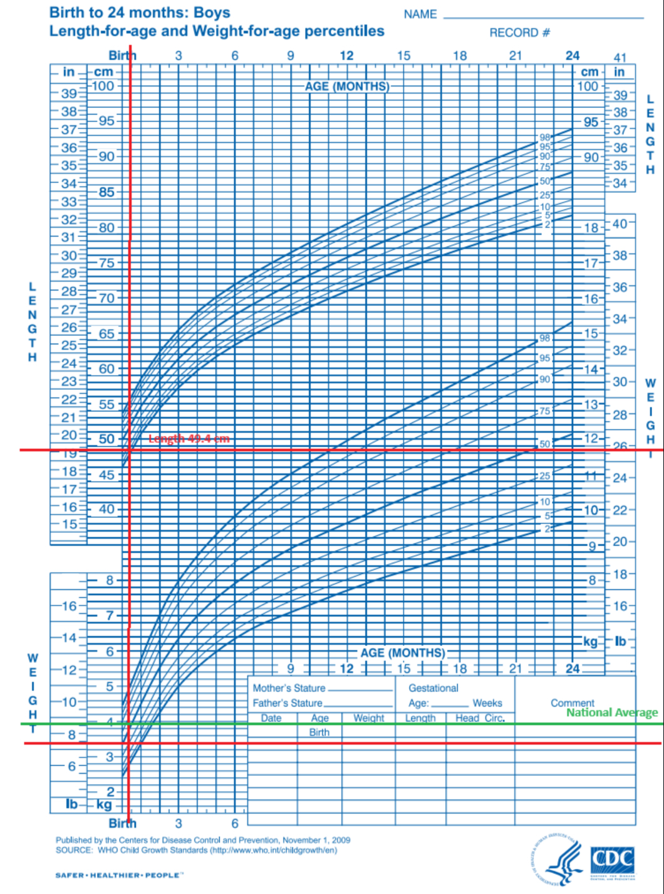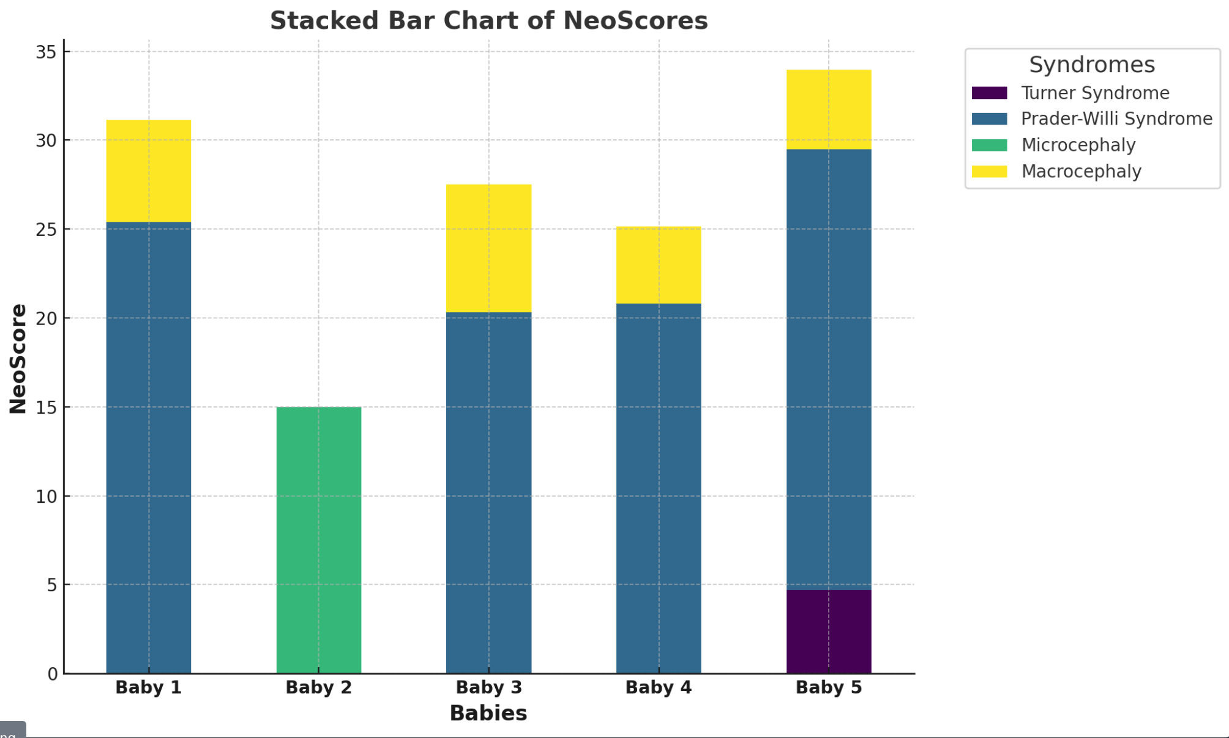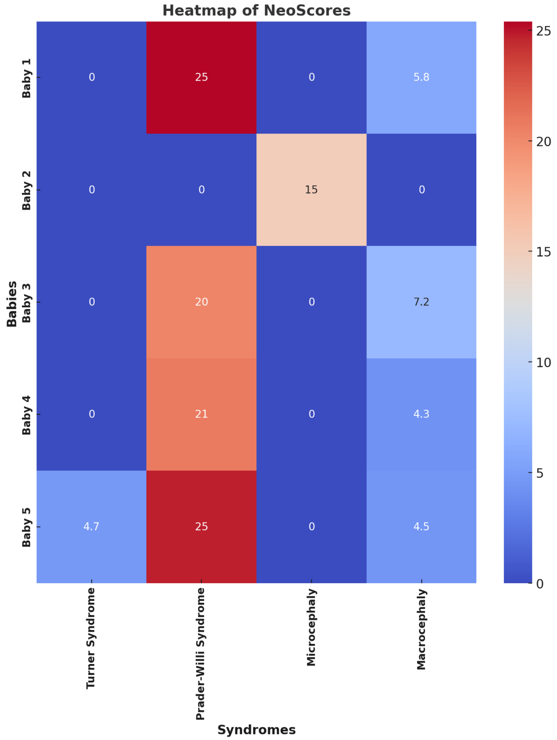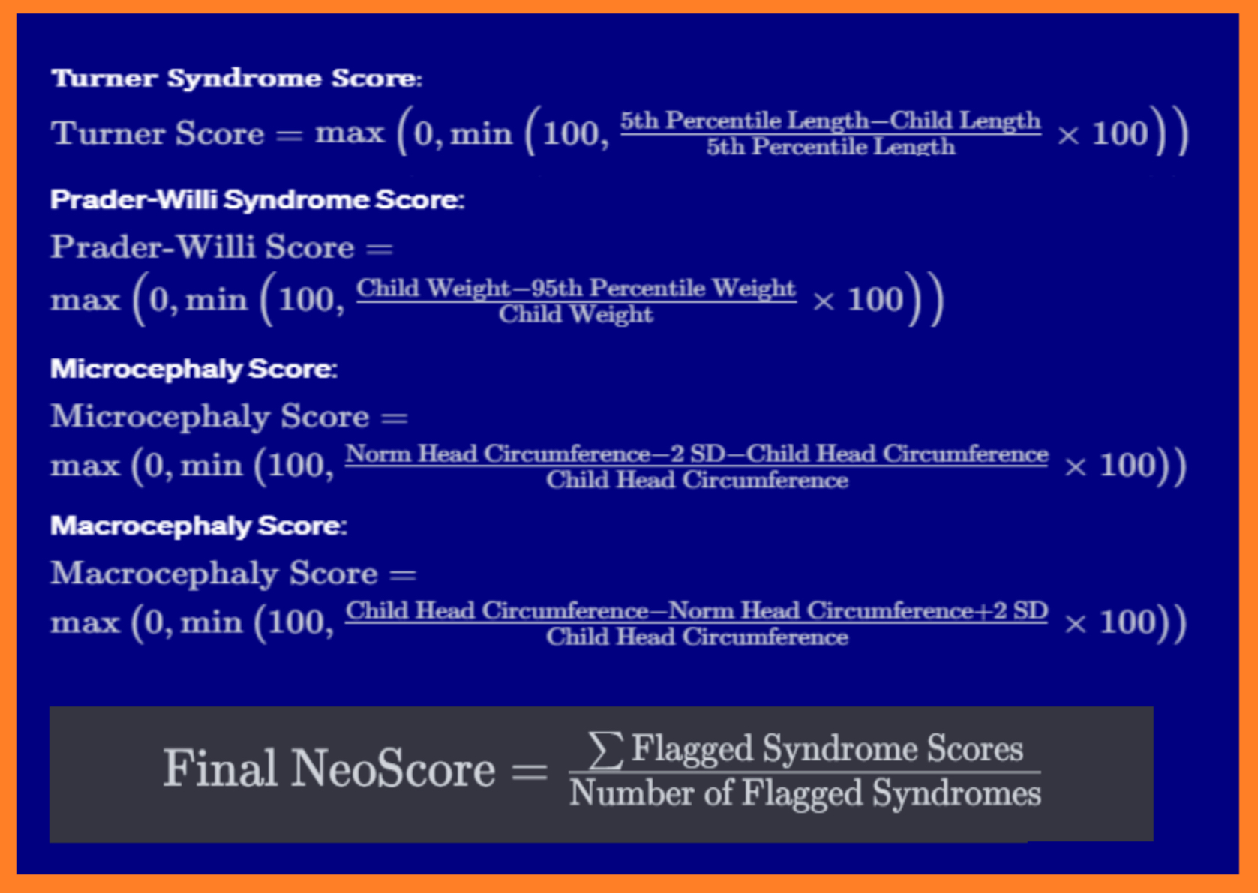

**Analysis**

The experiment produced a method of assessing the lacking areas of a given subject when compared to three different genetic disorders. The assessment is represented through a system of analyzing the gaps in a child’s health, otherwise known as the NeoScore. There are multiple ways to demonstrate this assessment, including the heat map and the bar graph. The heat map includes a legend in which a deep blue sector represents no symptoms (a theoretically normal baby), lighter blue squares represent issues as they show less risk of having said syndromes progressively, and shades of red indicate severe concerns related to a disorder (with severity increasing from the lightest hue to the darkest). The stacked bar chart demonstrates division of NeoScores of the four different disorders between 5 subjects. The key shows which color corresponds to each genetic disorder and shows the magnitude of risk of a subject contracting a given disorder. The stacked bar chart is an effective representation of a subject’s NeoScore as it visually demonstrates the sum of all the ‘NeoScores’, or the child’s susceptibility to the three disorders that were tested. The equations used to derive the NeoScore are also products of the experiment, and form the basis of the project by finding the risk of each of the three genetic disorders in the child and averaging them to create a risk number, or ‘NeoScore’. The data concluded that the hypothesis was correct as the predictive model, in parallel to the website, helped the theoretical mothers identify different gaps in growth of their children early on so that they could be treated more effectively and efficiently by licensed professionals.

Turner Syndrome - Graph 1:

* The child is well above the 95th percentile in length and weight for age children we: child is at slight risk for Turner syndrome and macrocephaly

Microcephaly/Macrocephaly - Graph 2:

* Microcephaly: Child is well below 5th percentile in head circumference for age
* Macrocephaly: child is well above 95th percentile in head circumference

Both children at moderately high risk for microcephaly and all other four use cases at slight to moderate risk for macrocephaly

Prader-Willi Syndrome - Graph 3:

* 4 children well above 95th percentile in appropriate weight bracket and showing high risk for prader-willi syndrome
* Children within weight bracket and at no risk (absolute 0) for prader willi syndrome

**Conclusion**

In conclusion, NeoCare proved the hypothesis correct in that it created a way for mothers to get more specialized care through the derivation of a ‘NeoScore’, which assesses risk for three different genetic disorders(Turner’s Syndrome, Microcephaly/Macrocephaly, and Prader-Willi Syndrome), and gives new mothers a definitive answer for potential neuro and physical dysfunctions in their children which can then be treated more effectively and efficiently by a licensed professional. The results were deduced through a combination of research, writing of the predictive and neural network models, and the use of VS Code and GitHub to bring the full project together. The research consisted of finding the importance of each CDC benchmark chart, discovering the different syndromes and characterizing them, and narrowing every category down to use cases. Due to the work of inputting the research data into the platforms as well as writing and testing the accuracy of the models, the results came back as a reliable predictive model to assess the risk of different neurological and physical disorders in children, therefore proving the hypothesis and helping new mothers have access to individualized neonatal care so that their children can be treated for potential neuro-dysfunctions through the help of licensed professionals. For example, Baby 1 was at a NeoScore of 25 for Prader-Willi Syndrome(extreme risk), as we tested data of an imaginary patient with Prader-Willi Syndrome. This imaginary child would have been able to go see a doctor and be properly treated due to the early stage discovery, proving our original hypothesis to increase the health of the mother and child by reducing stress and diagnosing symptoms early on. One of the major mistakes made was deciding what platform to use(website, app, or raw model) too late, as we had to pivot each time due to the experiment’s slight changes that were a result of the change. If these slight mistakes were avoided, the project would have gone a lot more smoothly, though it was already well planned and well thought out.

**References**

CDC. (2017, June 16). *Growth charts - clinical growth charts*. Centers for Disease Control and Prevention. https://www.cdc.gov/growthcharts/clinical_charts.htm

Fergus, K. (2023, October 27). *Common characteristics of down syndrome*. Verywell Health. https://www.verywellhealth.com/symptoms-of-down-syndrome-1120463

ACOG. (2021, February). *Cord blood banking*. https://www.acog.org/womens-health/faqs/cord-blood-banking#:~:text=Cord%20blood%20is%20the%20blood,make%20copies%20only%20of%20themselves.

Boston Children’s Hospital. (2023, February). *Growth problems*. Growth Problems | Boston Children’s Hospital. http://www.childrenshospital.org/conditions/growth-problems#:~:text=Growth%20problems%20may%20be%20a,growth%20hormone%20deficiency.

Wroblewski, M. E., Badik, C., & Bevington, J. (2015, September 1). *Head Growth*. Publications.aap.org. https://publications.aap.org/pediatricsinreview/article-abstract/36/9/426/34910/Head-Growth?redirectedFrom=fulltext

Robert H. Shmerling, M. (2023, May 5). *How useful is the body mass index (BMI)?*. Harvard Health. https://www.health.harvard.edu/blog/how-useful-is-the-body-mass-index-bmi-201603309339

Jones, S., & Debopam, S. (2023, June 24). *Macrocephaly - StatPearls - NCBI Bookshelf*. National Library of Medicine. https://www.ncbi.nlm.nih.gov/books/NBK560786/

Allen, M., & Sharma, S. (2023, January). Noonan syndrome - StatPearls - NCBI Bookshelf. https://www.ncbi.nlm.nih.gov/books/NBK532269/

Safer-Healthier-People. (2000, May). Overview of the CDC growth charts. https://www.cdc.gov/nccdphp/dnpa/growthcharts/training/modules/module2/text/module2print.pdf

Cleveland Clinic, M. P. (2023, January 27). *Prader-willi syndrome: Symptoms & causes*. https://my.clevelandclinic.org/health/diseases/21016-prader-willi-syndrome

Mayo Clinic. (2022, February 11). *Turner syndrome*. https://www.mayoclinic.org/diseases-conditions/turner-syndrome/symptoms-causes/syc-20360782

Kelvas, D. (2023, June). *Why body weight or BMI isn’t an indicator of health*. Why Body Weight or BMI Isn’t an Indicator of Health. https://withinhealth.com/learn/articles/why-body-weight-isnt-an-indicator-of-health